Detailed extraction results from various prominent tools

Experimentation Setup :
PDF used for extraction
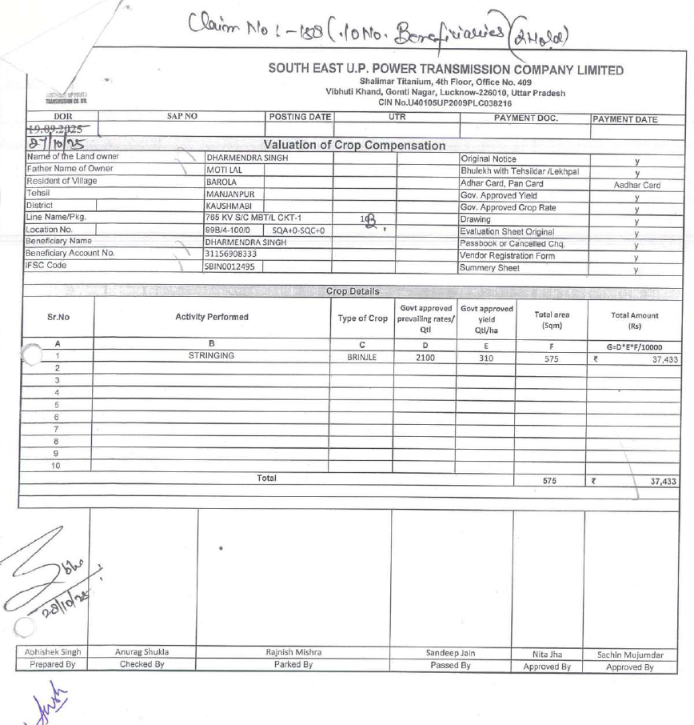

Landing AI’s Agentic Document Extraction :

agentic document extraction link : https://va.landing.ai/share/inference/cotwlhtn2lns9ds9z41xe8yi7

Results :

azure content understanding(ai foundary) :

---pdf OCR using Microsoft Azure-content understanding(Microsoft ai foundary)

OCR text link :
https://drive.google.com/file/d/1K4dqBVQXyDUSFbUlUL42V3rXFN4QeYvd/view?usp=sharing

Results :

azure document intelligence(OCR) :

---pdf OCR using Microsoft Azure-document intelligence studio(OCR)

OCR text link : https://drive.google.com/file/d/1PaZFnhCm6oEmcrfi6bh5BpIQsXQBS6UG/view?usp=sharing

Results :

Gemini :
---OCR as well as fields extraction both done using Gemini

Chat link : https://gemini.google.com/share/42ff6db30fbe

Results :
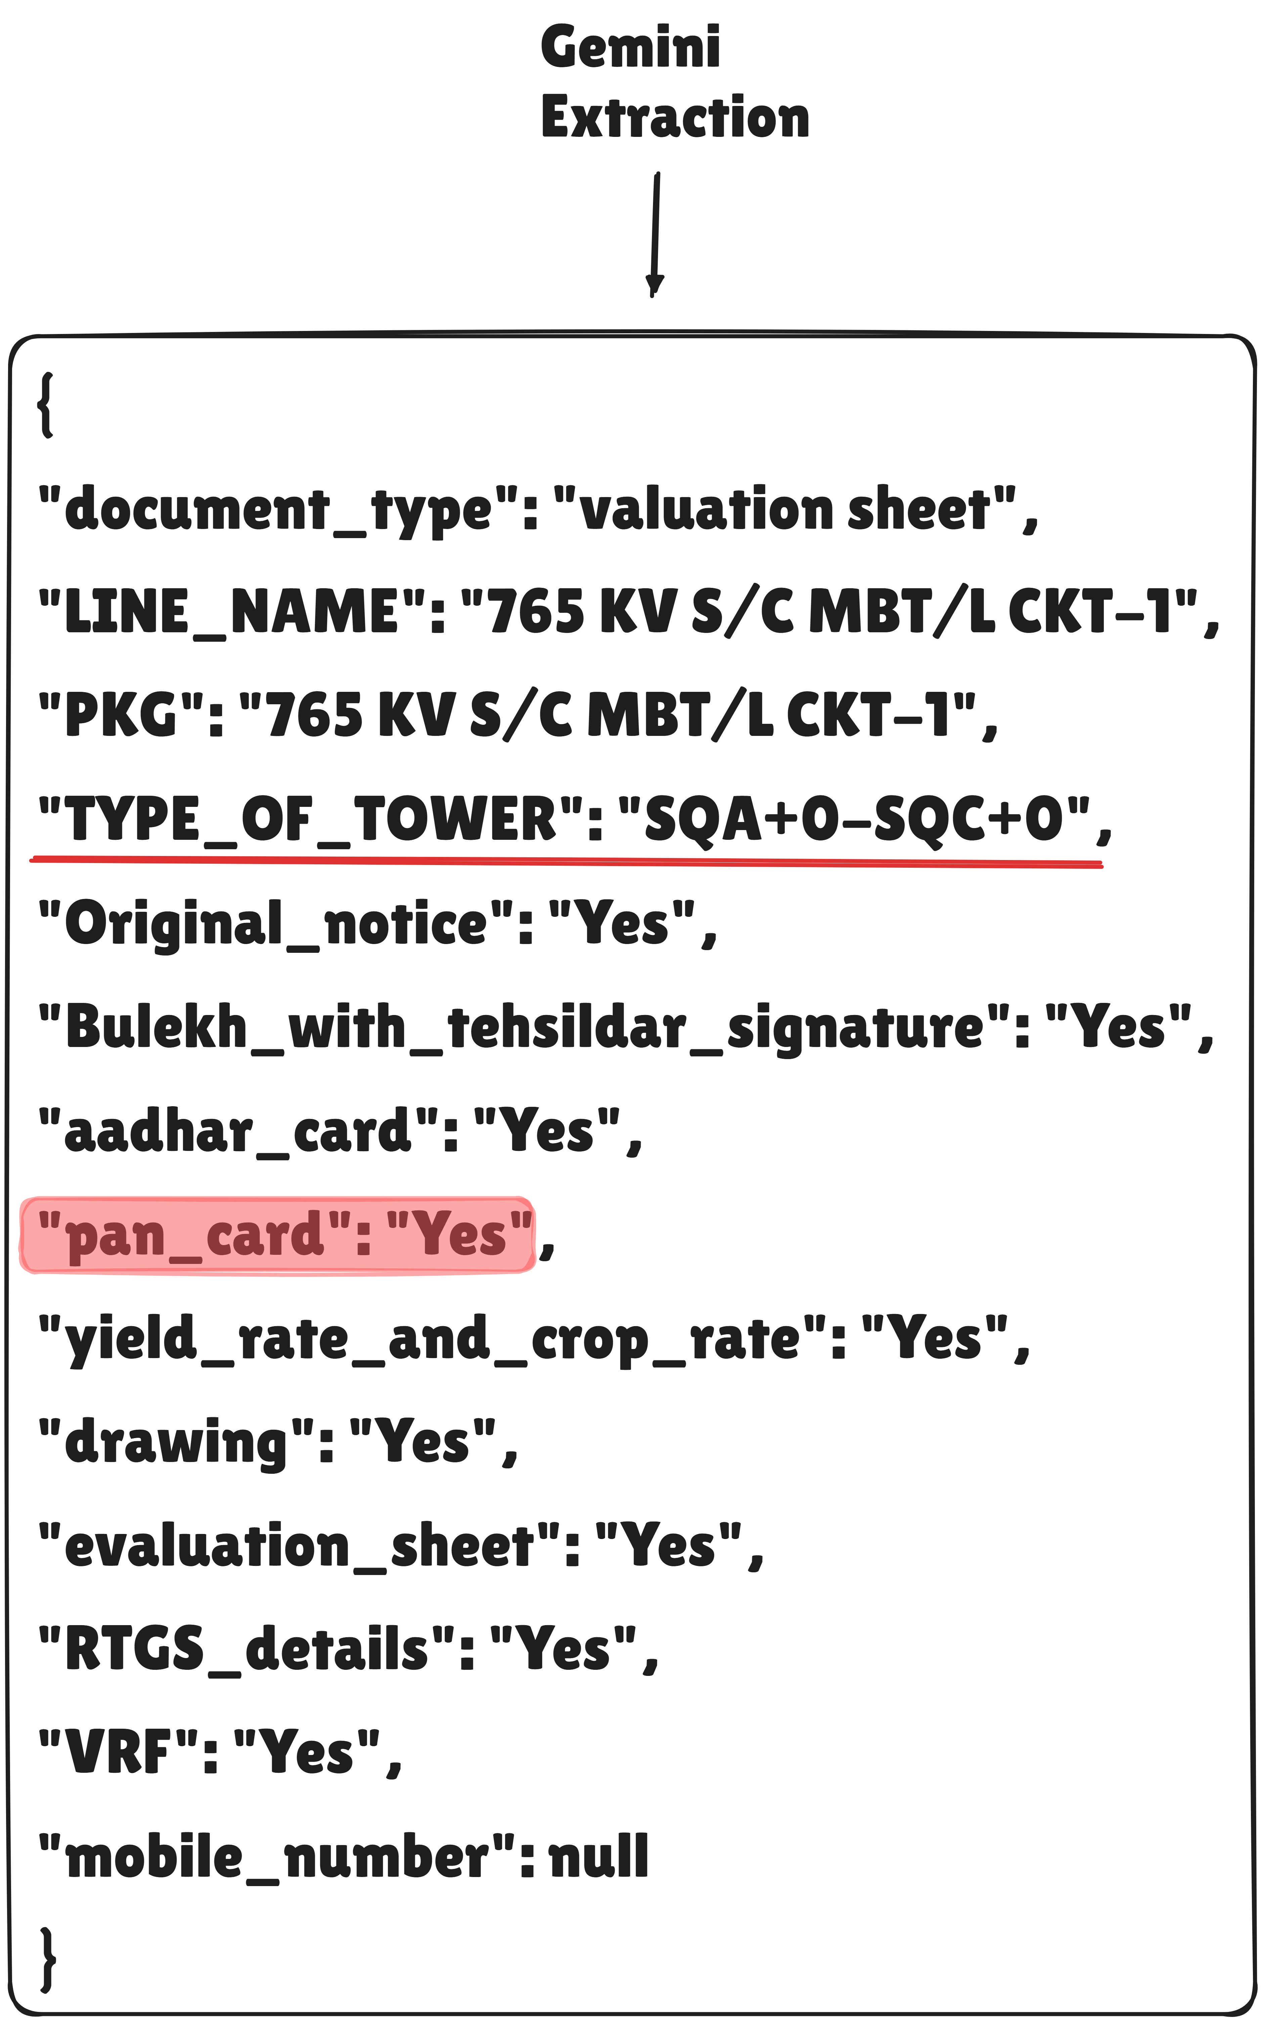

PRY Extraction :
---OCR done using PRY with out selecting ‘include’ option

OCR text link : https://drive.google.com/file/d/1KLXdysPAQzvlI3f1ibYZsNBvv2rCdn49/view?usp=sharing

Results :

PRY Extraction (include tabels in OCR text):
---OCR done using PRY with selecting ‘include’ option

OCR text link : https://drive.google.com/file/d/1E4-PUJ4wVxtEjYYxvnGzx6wZIThWiAPA/view?usp=sharing

Results :

